**Chapter-3: Software Project Analysis**

**3.1 DFD (upto 2nd level) or Class Diagram.**

A Data Flow Diagram (DFD) is a diagram that describes the flow of data and the processes that change or transform data throughout a system. The Data Flow Diagram reviews the current physical system, prepares input and output specification, specifies the implementation plan etc.

Four basic symbols are used to construct data flow diagrams. They are symbols that represent data source, data flows, and data transformations and data storage. The points at which data are transformed are represented by enclosed figures, usually circles, which are called nodes.

# Source of Destination of data

(B) **Flow of Data**

# (c) Process

# (D) Storage

Steps to Construct Data Flow Diagrams

Four steps are commonly used to construct a DFD

* Process should be named and numbered for easy reference. Each name should be representative of the process.
* The direction of flow is from top to bottom and from left to right.
* When a process is exploded into lower level details they are numbered.
* The names of data stores, sources and destinations are written in capital letters

Rules for Constructing a Data Flow Diagram

* Arrows should not cross each other.
* Squares, Circles and files must bear names.
* Decomposed data flow squares and circles can have same names.
* Choose meaningful names for dataflow.

Draw all data flows around the outside of the diagram

# Context Level Data Flow Diagram

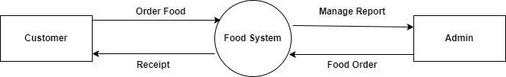

# Fig No-3.1: Context Level Data Flow Diagram

**First level Data Flow Diagram**

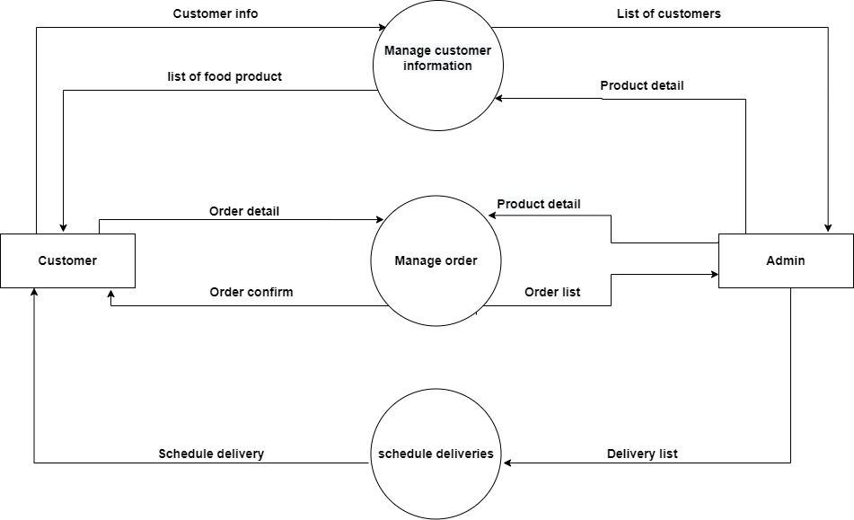

**Fig No-3.2: First level Data Flow Diagram**

# Second Level Data Flow Diagram

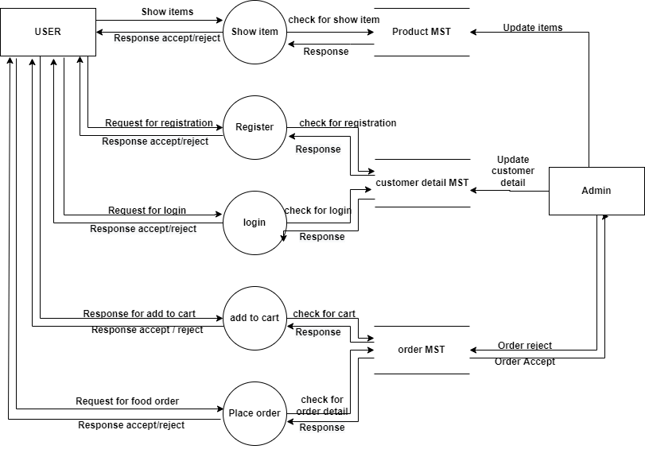

# Fig No-3.2: Second Level Data Flow Diagram

**3.2 Entity- Relationship Diagram**

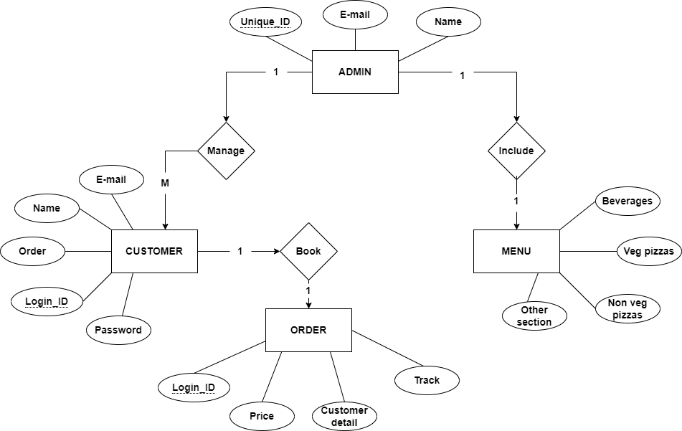

**Fig No-3.2.1 Entity- Relationship Diagram**

**3.3 Database Specifications:**

4.1. Table Name: Signup

Description- To store the customer Details

|  |  |  |  |
| --- | --- | --- | --- |
| **Field** | **Description** | **Type** | **Length** |
| **c**ust_ID (PK) | Customer ID | Int | 11 |
| Name | E-mail | Varchar | 255 |
| Password | Password | Text |  |

4.2. Table Name: Order

Description- To store the Order Details

|  |  |  |  |
| --- | --- | --- | --- |
| **Field** | **Description** | **Type** | **Length** |
| Order_ID | Order ID | Int | 11 |
| Cust_ID | Customer ID | Int | 11 |
| Food_ID | Food ID | Int | 11 |
| Quantity | Quantity of Order | Int | 11 |

4.3. Table Name: menu

Description- To store the menu detail

|  |  |  |  |
| --- | --- | --- | --- |
| **Field** | **Description** | **Type** | **Length** |
| food_ID | Food ID | Int | 11 |
| Name | Food Name | Int | 11 |
| Size | Size | Text |  |
| Price | Price | Varchar | 11 |